**ASSIGNMENT-7**

Subject – Computer Science Workshop-1(CSE 2141)

NAME – DEEPTESH ROUT

Registration Number – 2341018166

Section – 23412G1 Branch – B. Tech (CSE)

/*Q1Write a Java program to count the number of bits that are set to 1 in an integer.

JAVA CODE

public class ASS7_Q1 {

    // Function to count the number of 1 bits in an integer

    public static int countSetBits(int number) {

        int count = 0;

        while (number != 0) {

            count += number & 1; // Increment count if the last bit is 1

            number >>>= 1;       // Unsigned right shift

        }

        return count;

    }

    public static void main(String[] args) {

        // Example usage

        int number = 29; // Binary representation: 11101

        int result = countSetBits(number);

        System.out.println("The number of 1 bits in " + number + " is: " + result);

    }

}

OUTPUT

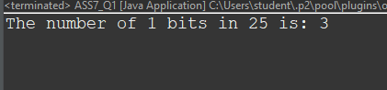

Q2 Theparity of a binary word is 1 if the number of 1s in the word is odd; otherwise, it is 0. Write a Java program to count the parity of an integer number.

JAVA CODE :-

import java.util.Scanner;

public class ASS7_Q2 {

    // Method to calculate the parity of a number

    public static int calculateParity(int number) {

        int count = 0;

        // Count the number of 1s in the binary representation

        while (number != 0) {

            count += number & 1; // Add 1 if the least significant bit is 1

            number >>= 1;        // Right shift the number by 1 bit

        }

        // Return 1 if the count is odd, 0 otherwise

        return count % 2;

    }

    public static void main(String[] args) {

        Scanner scanner = new Scanner(System.in);

        // Input: Get the integer from the user

        System.out.print("Enter an integer: ");

        int number = scanner.nextInt();

        // Calculate the parity

        int parity = calculateParity(number);

        // Output the result

        System.out.println("The parity of the number is: " + parity);

        scanner.close();

    }

}

OUTPUT :-

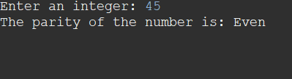

Q3.Write a program to swap the ith bit with jth bit of a number.

JAVA CODE :-

public class ASS7_Q3 {

    public static int swapBits(int number, int i, int j) {

        // Extract the i-th and j-th bits

        int bit1 = (number >> i) & 1;

        int bit2 = (number >> j) & 1;

        // If the bits are the same, no need to swap

        if (bit1 == bit2) {

            return number;

        }

        // Create a bitmask with the i-th and j-th bits set

        int bitMask = (1 << i) | (1 << j);

        // Toggle the i-th and j-th bits using XOR

        return number ^ bitMask;

    }

    public static void main(String[] args) {

        int number = 73; // Example number (binary: 1001001)

        int i = 1;       // Position of first bit (0-based indexing)

        int j = 6;       // Position of second bit (0-based indexing)

        System.out.println("Original number: " + number + " (Binary: " + Integer.toBinaryString(number) + ")");

        int result = swapBits(number, i, j);

        System.out.println("After swapping: " + result + " (Binary: " + Integer.toBinaryString(result) + ")");

    }

}

OUTPUT:-

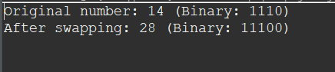

Q4. Write a program that takes a 64-bit word and returns the 64-bit word consisting of the bits of the input word in reverse order. For example, if the input is alternating 1s and 0s, i.e., (1010...10), the output should be alternating 0s and 1s, i.e.,(0101...01).

JAVA CODE

public class ASS7_Q4 {

    public static long reverseBits(long number) {

        long reversed = 0; // Initialize the reversed number

        for (int i = 0; i < 64; i++) {

            // Extract the least significant bit of the number

            long bit = number & 1;

            // Shift the bit to its reversed position and add it to reversed

            reversed = (reversed << 1) | bit;

            // Shift the input number to the right to process the next bit

            number >>= 1;

        }

        return reversed;

    }

    public static void main(String[] args) {

        long input = 0xAAAAAAAAAAAAAAAAL; // Example: alternating 1s and 0s

        System.out.println("Input (Binary): " + Long.toBinaryString(input));

        long output = reverseBits(input);

        System.out.println("Output (Binary): " + Long.toBinaryString(output));

    }

}

OUTPUT :-



Q5. Write a java program to copmute x×y without arithmetic operators.

JAVA CODE

public class ASS7_Q5 {

    public static int multiply(int x, int y) {

        int result = 0; // Initialize result to 0

        // Iterate through all bits of y

        while (y != 0) {

            // If the least significant bit of y is set, add x to the result

            if ((y & 1) != 0) {

                result = add(result, x);

            }

            // Shift x to the left (equivalent to multiplying by 2)

            x <<= 1;

            // Shift y to the right (equivalent to dividing by 2)

            y >>= 1;

        }

        return result;

    }

    // Helper method to add two integers without using the '+' operator

    private static int add(int a, int b) {

        while (b != 0) {

            // Calculate carry

            int carry = a & b;

            // Perform addition without carry

            a = a ^ b;

            // Shift carry left by 1 to add it in the next iteration

            b = carry << 1;

        }

        return a;

    }

    public static void main(String[] args) {

        int x = 7; // Example input

        int y = 3; // Example input

        System.out.println("x: " + x + ", y: " + y);

        System.out.println("x * y: " + multiply(x, y));

    }

}

OUTPUT :-

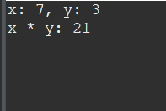

Q6. Write a java program to copmute x/y without arithmetic operators.

JAVA CODE :-

public class ASS7_Q6 {

    public static int divide(int dividend, int divisor) {

        // Handle edge cases for division by 0

        if (divisor == 0) {

            throw new ArithmeticException("Division by zero is undefined.");

        }

        // Handle overflow case when dividing Integer.MIN_VALUE by -1

        if (dividend == Integer.MIN_VALUE && divisor == -1) {

            return Integer.MAX_VALUE;

        }

        // Determine the sign of the result

        boolean negative = (dividend < 0) ^ (divisor < 0);

        // Work with positive values for simplicity

        long absDividend = Math.abs((long) dividend);

        long absDivisor = Math.abs((long) divisor);

        int result = 0;

        // Perform division using bitwise operations

        while (absDividend >= absDivisor) {

            long tempDivisor = absDivisor;

            int multiple = 1;

            // Shift tempDivisor left until it's greater than absDividend

            while (absDividend >= (tempDivisor << 1)) {

                tempDivisor <<= 1;

                multiple <<= 1;

            }

            // Subtract tempDivisor from absDividend and add multiple to result

            absDividend -= tempDivisor;

            result += multiple;

        }

        // Apply the sign to the result

        return negative ? -result : result;

    }

    public static void main(String[] args) {

        int dividend = 43; // Example dividend

        int divisor = 5;   // Example divisor

        System.out.println("Dividend: " + dividend + ", Divisor: " + divisor);

        System.out.println("Quotient: " + divide(dividend, divisor));

    }

}

OUTPUT :-

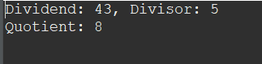

Q7. Write a program to find xy.

JAVA CODE

public class ASS7_Q7 {

    public static long power(int x, int y) {

        if (y < 0) {

            throw new IllegalArgumentException("Negative powers are not supported.");

        }

        long result = 1;

        long base = x;

        // Perform exponentiation using bitwise operations

        while (y > 0) {

            // If the current bit of y is 1, multiply result by base

            if ((y & 1) == 1) {

                result *= base;

            }

            // Square the base and shift y to the right

            base *= base;

            y >>= 1;

        }

        return result;

    }

    public static void main(String[] args) {

        int x = 3; // Base

        int y = 4; // Exponent

        System.out.println(x + " raised to the power " + y + " is: " + power(x, y));

    }

}

OUTPUT :-



Q8. Write a program to find the reverse of a number. For example, if the input is 123 output is 321, and if the input is-245 output is-542

JAVA CODE :-

public class ASS7_Q8 {

    public static int reverse(int number) {

        int reversed = 0;

        while (number != 0) {

            // Extract the last digit

            int digit = number % 10;

            // Check for overflow/underflow before adding the digit

            if (reversed > Integer.MAX_VALUE / 10 || reversed < Integer.MIN_VALUE / 10) {

                throw new ArithmeticException("Overflow occurred during reversal.");

            }

            // Add the digit to the reversed number

            reversed = reversed * 10 + digit;

            // Remove the last digit from the number

            number /= 10;

        }

        return reversed;

    }

    public static void main(String[] args) {

        int input = -245; // Example input

        System.out.println("Original number: " + input);

        System.out.println("Reversed number: " + reverse(input));

    }

}

OUTPUT :-



Q9. Write a program to check whether a number is palindrome or not.

JAVA CODE :-

public class ASS7_Q9 {

    public static boolean isPalindrome(int number) {

        // Negative numbers are not palindromes

        if (number < 0) {

            return false;

        }

        int original = number; // Store the original number

        int reversed = 0;

        // Reverse the number

        while (number != 0) {

            int digit = number % 10;

            // Check for overflow

            if (reversed > Integer.MAX_VALUE / 10) {

                return false; // Overflow indicates it's not a valid palindrome

            }

            reversed = reversed * 10 + digit;

            number /= 10;

        }

        // Check if the reversed number equals the original

        return original == reversed;

    }

    public static void main(String[] args) {

        int input = 121; // Example input

        System.out.println("Is " + input + " a palindrome? " + isPalindrome(input));

        int input2 = -121; // Another example input

        System.out.println("Is " + input2 + " a palindrome? " + isPalindrome(input2));

    }

}

OUTPUT :-

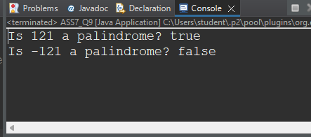

Q10. Write a Java program that reads two float numbers and checks whether the difference between these two numbers is less than ϵ (ϵ < 1).

package mypackage;

import java.util.Scanner;

public class ASS7_Q10 {

    public static void main(String[] args) {

        // Create a scanner for user input

        Scanner scanner = new Scanner(System.in);

        // Read two float numbers from the user

        System.out.print("Enter the first float number: ");

        float num1 = scanner.nextFloat();

        System.out.print("Enter the second float number: ");

        float num2 = scanner.nextFloat();

        // Define epsilon (threshold)

        final float EPSILON = 0.0001f; // Example: very small value less than 1

        // Calculate the absolute difference

        float difference = Math.abs(num1 - num2);

        // Check if the difference is less than epsilon

        if (difference < EPSILON) {

            System.out.println("The difference between the two numbers is less than " + EPSILON);

        } else {

            System.out.println("The difference between the two numbers is greater than or equal to " + EPSILON);

        }

        // Close the scanner

        scanner.close();

    }

}

OUTPUT :-

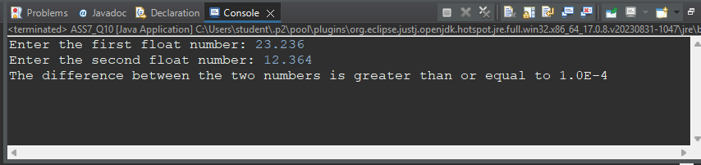

Q11. Write a Java program that reads an integer number and counts the number of digits that are even.

JAVA CODE :-

import java.util.Scanner;

public class ASS7_Q11 {

    public static void main(String[] args) {

        // Create a scanner for user input

        Scanner scanner = new Scanner(System.in);

        // Read an integer number from the user

        System.out.print("Enter an integer: ");

        int number = scanner.nextInt();

        // Handle negative numbers by converting to positive

        number = Math.abs(number);

        int evenCount = 0; // Initialize count of even digits

        // Count even digits

        while (number > 0) {

            int digit = number % 10; // Extract the last digit

            // Check if the digit is even

            if (digit % 2 == 0) {

                evenCount++;

            }

            number /= 10; // Remove the last digit

        }

        // Output the count of even digits

        System.out.println("Number of even digits: " + evenCount);

        // Close the scanner

        scanner.close();

    }

}

OUTPUT : -

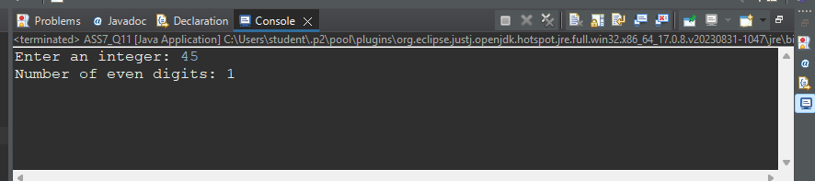

Q12. Write a Java program that reads two integer number and create a third number by taking the first two digits of the first number and the last two digits of the second number. Example: Input: 45678, 312 Output:4512.

JAVA CODE :-

import java.util.Scanner;

public class ASS7_Q12 {

    public static int createNumber(int num1, int num2) {

        // Extract the first two digits of the first number

        int firstTwoDigits = num1 / (int)Math.pow(10, (int)Math.log10(num1) - 1); // Divide num1 by 10^(number of digits - 2)

        // Extract the last two digits of the second number

        int lastTwoDigits = num2 % 100; // Get the remainder when divided by 100

        // Combine them into a new number

        return firstTwoDigits * 100 + lastTwoDigits;

    }

    public static void main(String[] args) {

        // Create a scanner for user input

        Scanner scanner = new Scanner(System.in);

        // Read two integer numbers from the user

        System.out.print("Enter the first number: ");

        int num1 = scanner.nextInt();

        System.out.print("Enter the second number: ");

        int num2 = scanner.nextInt();

        // Call the method to create the new number

        int result = createNumber(num1, num2);

        // Output the result

        System.out.println("The new number is: " + result);

        // Close the scanner

        scanner.close();

    }

}

OUTPUT :-

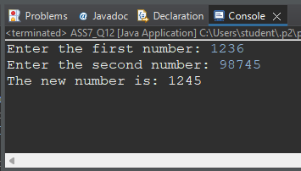

Q13. Write a Java program to count the frequency of each digit of a number.

JAVA CODE

import java.util.Scanner;

public class ASS7_Q13 {

    public static void countDigitFrequency(int number) {

        // Create an array to store frequency of each digit (0-9)

        int[] frequency = new int[10];

        // Handle negative numbers by converting to positive

        number = Math.abs(number);

        // Process each digit of the number

        while (number > 0) {

            int digit = number % 10; // Extract the last digit

            frequency[digit]++;      // Increment the frequency of that digit

            number /= 10;            // Remove the last digit

        }

        // Output the frequency of each digit

        System.out.println("Digit frequencies:");

        for (int i = 0; i < 10; i++) {

            if (frequency[i] > 0) {

                System.out.println("Digit " + i + ": " + frequency[i]);

            }

        }

    }

    public static void main(String[] args) {

        // Create a scanner for user input

        Scanner scanner = new Scanner(System.in);

        // Read an integer number from the user

        System.out.print("Enter a number: ");

        int number = scanner.nextInt();

        // Call the method to count the digit frequency

        countDigitFrequency(number);

        // Close the scanner

        scanner.close();

    }

}

OUTPUT :-

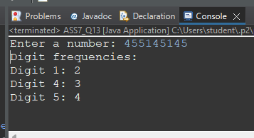

Q14. Write a Java program to check whether a number is prime or not.

JAVA CODE

import java.util.Scanner;

public class ASS7_Q14 {

    public static boolean isPrime(int number) {

        // Handle edge cases

        if (number <= 1) {

            return false; // Numbers less than or equal to 1 are not prime

        }

        // Check divisibility from 2 to the square root of the number

        for (int i = 2; i * i <= number; i++) {

            if (number % i == 0) {

                return false; // If divisible by any number, it's not prime

            }

        }

        return true; // If no divisors found, it's prime

    }

    public static void main(String[] args) {

        // Create a scanner for user input

        Scanner scanner = new Scanner(System.in);

        // Read an integer number from the user

        System.out.print("Enter a number: ");

        int number = scanner.nextInt();

        // Check if the number is prime

        if (isPrime(number)) {

            System.out.println(number + " is a prime number.");

        } else {

            System.out.println(number + " is not a prime number.");

        }

        // Close the scanner

        scanner.close();

    }

}

OUTPUT

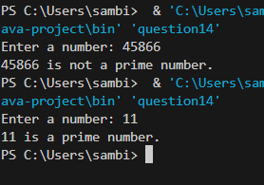

Q15 . Write a program to print the first 100th prime number

public class ASS7_Q15 {

    // Method to check if a number is prime

    public static boolean isPrime(int number) {

        if (number <= 1) {

            return false; // Numbers less than or equal to 1 are not prime

        }

        // Check divisibility from 2 to the square root of the number

        for (int i = 2; i * i <= number; i++) {

            if (number % i == 0) {

                return false; // If divisible by any number, it's not prime

            }

        }

        return true; // If no divisors found, it's prime

    }

    public static void main(String[] args) {

        int count = 0; // To count prime numbers

        int number = 2; // Start checking from the number 2

        while (count < 100) { // Keep going until we find the 100th prime

            if (isPrime(number)) {

                count++; // If it's prime, increment the count

            }

            number++; // Move to the next number

        }

        // Output the 100th prime number

        System.out.println("The 100th prime number is: " + (number - 1));

    }

}

OUTPUT :-

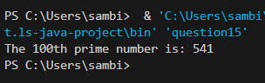

Q16. Write a Java program to print the prime number in a range.

JAVA CODE :-

import java.util.Scanner;

public class ASS7_Q16 {

    // Method to check if a number is prime

    public static boolean isPrime(int number) {

        if (number <= 1) {

            return false; // Numbers less than or equal to 1 are not prime

        }

        // Check divisibility from 2 to the square root of the number

        for (int i = 2; i * i <= number; i++) {

            if (number % i == 0) {

                return false; // If divisible by any number, it's not prime

            }

        }

        return true; // If no divisors found, it's prime

    }

    public static void main(String[] args) {

        // Create a scanner for user input

        Scanner scanner = new Scanner(System.in);

        // Read the range from the user

        System.out.print("Enter the starting number of the range: ");

        int start = scanner.nextInt();

        System.out.print("Enter the ending number of the range: ");

        int end = scanner.nextInt();

        // Print the prime numbers in the given range

        System.out.println("Prime numbers between " + start + " and " + end + " are:");

        for (int i = start; i <= end; i++) {

            if (isPrime(i)) {

                System.out.print(i + " ");

            }

        }

        // Close the scanner

        scanner.close();

    }

}

OUTPUT :-

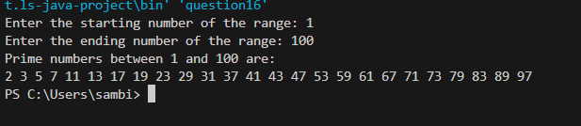

Q17. . Write a java program to find the minimum and maximum element in an array.

JAVA CODE :-

import java.util.Scanner;

public class ASS7_Q18 {

    // Method to check if a number is even

    public static boolean isEven(int number) {

        // Return true if the number is divisible by 2, otherwise return false

        return number % 2 == 0;

    }

    public static void main(String[] args) {

        // Create a scanner for user input

        Scanner scanner = new Scanner(System.in);

        // Read an integer number from the user

        System.out.print("Enter a number: ");

        int number = scanner.nextInt();

        // Call the method to check if the number is even and print the result

        System.out.println(isEven(number));

        // Close the scanner

        scanner.close();

    }

}

OUTPUT

